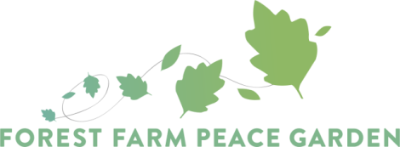

Garden Maintenance Volunteer Role Description

Forest Farm Peace Garden aims to run volunteer open days every Monday from 11:30am to 3:30pm (apart from bank holidays). Our volunteer open days can be accessed by members of the public who have undertaken a garden induction. Inductions for new volunteers will be held after receiving an application form. Inductions are held usually on the first Monday of the month at 11am or as advertised.

Please email on info@forestfarmpeacegarden.org to register your interest in attending a Monday garden maintenance day.

Activities
Activities will focus on general garden maintenance with a range of tasks from light to heavy, suitable for different abilities, for example:
- Light weeding of vegetable and perennial beds
- Clearing bramble and overgrowth to clear areas
- Weeding and wood-chipping pathways
- Preparing garden areas for use such as digging and mulching
- General tasks and repairs around the site
- Specific site development projects such as pond area, installing new beds etc

Requirements for the role
- Ability to do tasks independently and follow basic guidance with minimal supervision. We are not able to provide one to one support, although there will be other volunteers and staff around to ask questions if you need to.
- Some knowledge and experience of gardening or outdoors work is desirable, although some staff guidance is provided.
- Commitment to treat others fairly and with respect.
- Awareness of health and safety, how to use tools and carry out tasks safely.

Please note: if you have been part of our ecotherapy programme and have finished your placement you are welcome to join Monday garden sessions if you can demonstrate the above requirements. Please be aware that there will be no support from buddy volunteers in the garden as these sessions are for independent volunteering. You are able to bring a support worker or friend/family member if you need any additional support. Please discuss the role with the Ecotherapy Worker. We are offering this role on a 6 session trial basis to make sure that it is mutually beneficial to you and FFPG.

